**AUC – ROC Curve**

**What is the AUC - ROC Curve?**

AUC – ROC stands for Area Under Curve for Receiver Operating Characteristic curve. AUC - ROC curve is a performance measurement for classification problems at various threshold settings. ROC is a probability curve and the AUC score represents the degree or measure of separability. It tells how much the model is capable of distinguishing between classes. Higher the AUC score, the better the model is at predicting 0 classes as 0 and 1 classes as 1. By analogy, the Higher the AUC score, the better the model is at distinguishing between two classes, and thus the model in comparison to others becomes better.

The ROC curve is plotted with TPR against the FPR where TPR is on the y-axis and FPR is on the x-axis.

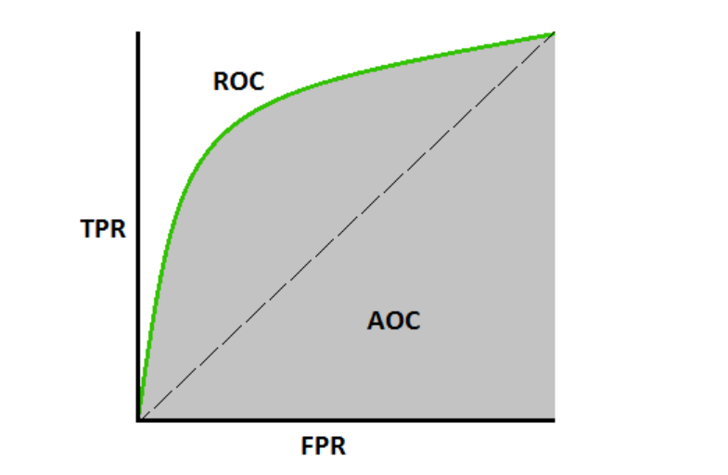

* TPR: {True Positive Rate} or {Sensitivity} or {Recall}
  + *TPR = true positives / (true positives + false negatives)*
* FPR: {False Positive Rate} or {1-Specificity}
  + *FPR = false positives/ (false positives + false negatives)*

# ****How to speculate about the performance of the model?****

An excellent model has AUC near to the 1 which means it has a good measure of separability. A poor model has an AUC near 0 which means it has the worst measure of separability. In fact, it means it is reciprocating the result. It is predicting 0s as 1s and 1s as 0s. And when AUC is 0.5, it means the model has no class separation capacity whatsoever.

Let’s interpret the above statements.

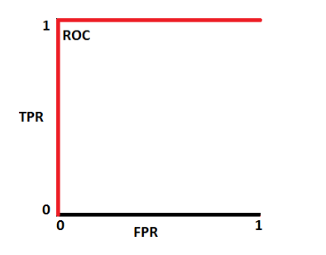

AUC score =1. This is an ideal situation. When two curves don’t overlap at all means the model has an ideal measure of separability. It is perfectly able to distinguish between positive class and negative class.

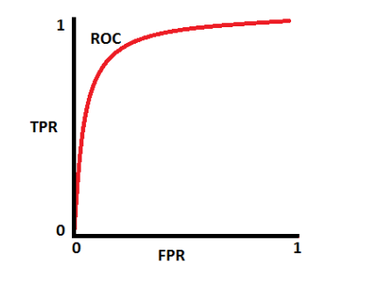

When AUC score = 0.7, it means there is a 70% chance that the model will be able to distinguish between positive class and negative class.

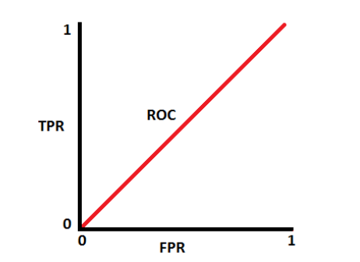

When AUC score = 0.5, the model has no discrimination capacity to distinguish between positive class and negative class.

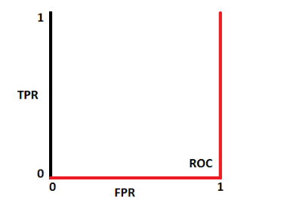

When AUC score = 0 , the model is predicting a negative class as a positive class and vice versa.

# ****Python Code:****

# 